F1 Handover Guide of 5G Setup with OAI-RAN and Open5GS on GCP
F1 Handover Guide of 5G Setup with OAI-RAN and Open5GS on GCP
This guide provides a complete, step-by-step walkthrough for deploying a virtualized 5G Standalone (SA) network on Google Cloud Platform (GCP). It uses OpenAirInterface (OAI) for the Radio Access Network (RAN) and Open5GS for the 5G Core (5GC).
The final architecture will consist of a consolidated OAI CU-CP/CU-UP, two OAI DUs, and a simulated OAI UE, configured to demonstrate a successful F1 handover between the two DUs.

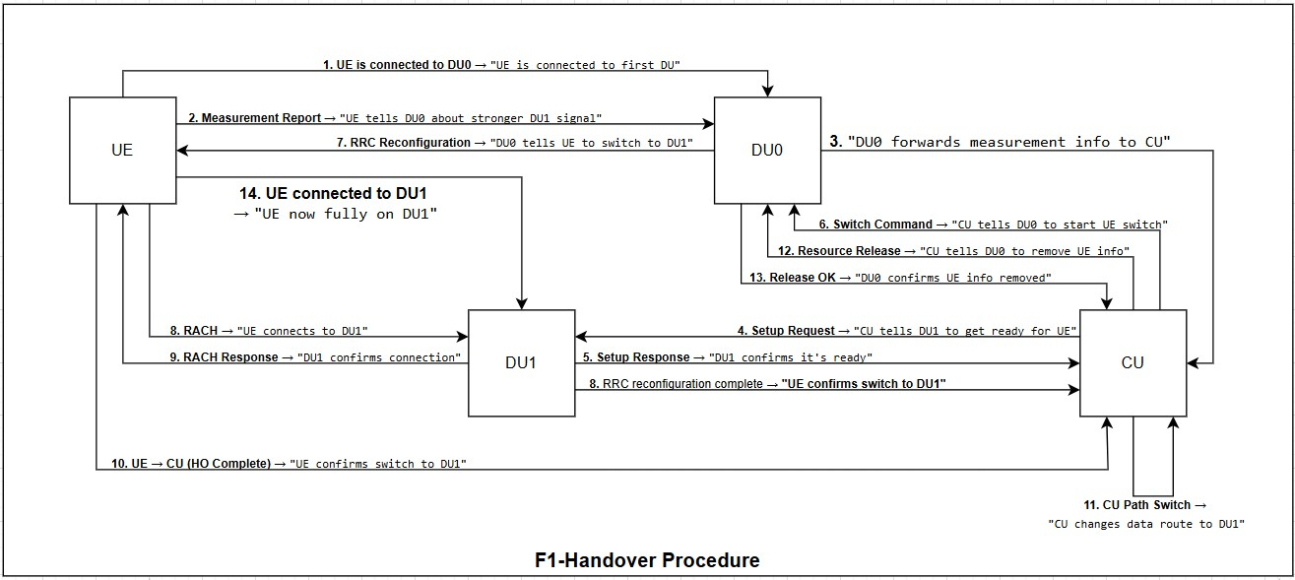
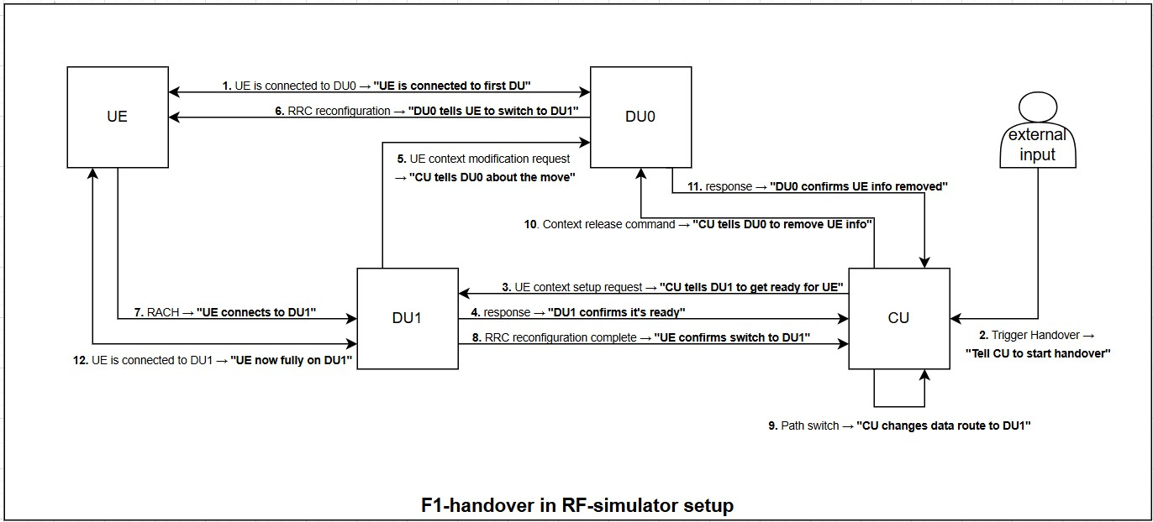

Part 1: GCP Environment and Cost Management

Leveraging the GCP Free Trial
Google Cloud offers a 90-day, $300 free trial for new users, which is more than sufficient to cover all costs for this deployment.

Machine Types: We will use a mix o
VMs. The OAI RAN

components require the N2 series for critical CPU instruction set support (AVX-512).
Cost Estimation: With the $300 credit, the cost for this entire setup during the trial period will be $0.
⚠ Important: Cleanup! To avoid any charges after the trial ends, you must shut down and delete your created resources as outlined in the final section of this guide.

Initial Project Setup
    - Navigate to the Google Cloud Console.
    - Create a new GCP project. Give it a memorable name like .
5g-f1-handover-proj
    - Ensure that billing is enabled for the project by linking your free trial billing account.

VPC Network and Firewall Configuration

Create a VPC:
Navigate to VPC network > VPC networks. Click CREATE VPC NETWORK.

Name:
oai-5g-vpc
Subnet creation mode: Custom

New subnet:
Name:
oai-subnet

Region:
us-central1
IP address range: Click Create.
172.17.0.0/24

Configure Firewall Rules:
(or another cost-effective US region)

Navigate to VPC network > Firewall. Rule 1: Allow SSH (for management)
Click CREATE FIREWALL RULE.

Name:
allow-ssh
Network:
oai-5g-vpc
Targets: All instances in the network
Source filter: IPv4 ranges
Source IPv4 ranges: (allows SSH from any IP)
0.0.0.0/0
Protocols and ports: Specified protocols and ports > Click Create.
tcp:22

Rule 2: Allow Internal Communication
Click CREATE FIREWALL RULE.

Name:
allow-internal-all
Network:
oai-5g-vpc
Targets: All instances in the network
Source filter: IPv4 ranges

Source IPv4 ranges:
172.17.0.0/24
Protocols and ports: Allow all Click Create.

Configure Cloud NAT for Internet Access:
(the range of our subnet)

To allow the UE to access the internet through the 5G core, we'll use a Cloud NAT instead

of
.
Navigate to Network services > Cloud NAT.
iptables
Click GET STARTED or CREATE NAT GATEWAY.
Gateway name:
oai-5g-nat
VPC network:
oai-5g-vpc
Region:
us-central1
Cloud Router: Click Create new router, name it Leave other settings as default and click Create.
oai-5g-router

, and click Create.

Part 2: Provisioning Virtual Machines
Create five VMs with static internal IPs.

Reserve Static Internal IPs:
Navigate to VPC network > IP addresses and click RESERVE INTERNAL STATIC IP ADDRESS five times for the following IPs:
172.17.0.91 | (for | oai-nr-ue-vm )
172.17.0.92 | (for | oai-du0-vm )
172.17.0.93 | (for | oai-cu-vm )
172.17.0.94 | (for | oai-du1-vm )
172.17.0.95 | (for | open5gs-vm )

Create the Virtual Machines:

Navigate to Compute Engine > VM instances and click CREATE INSTANCE for each VM.

VM Creation: Open5GS Core ( ) Name:
open5gs-vm
open5gs-vm
e2-small
Machine type:
Boot disk: Ubuntu 24.04 LTS, 30 GB
Under Advanced options > Networking: Network:
oai-5g-vpc
Primary internal IP: The reserved .
172.17.0.95
External IPv4 address: Ephemeral Check Enable IP forwarding.

VM Creation: All OAI RAN VMs
oai-du1-vm
oai-du0-vm
oai-nr-ue-vm

Create the four OAI VMs ( with the following settings:
oai-cu-vm
,
,
, )

Name: The respective VM name from the table below.
Series: N2 (Critical for AVX-512 support)
Machine type: n2-standard-4 (4 vCPU, 16 GB memory)
Boot disk: Ubuntu 24.04 LTS, 30 GB Under Advanced options > Networking:

Network:
oai-5g-vpc
Primary internal IP: Select the corresponding reserved IP from the table.
External IPv4 address: Ephemeral (for SSH access).

VM Roles and IPs:

Final Role | GCP VM Name | Reserved Static IP
Open5GS Core | open5gs-vm | 172.17.0.95
OAI CU-CP & CU-UP | oai-cu-vm | 172.17.0.93
OAI Source DU (DU0) | oai-du0-vm | 172.17.0.92
OAI Target DU (DU1) | oai-du1-vm | 172.17.0.94
OAI NR-UE (RF Server) | oai-nr-ue-vm | 172.17.0.91

Part 3: Setting up SSH for VS Code and Google Cloud
This guide details the steps required to securely connect to your Google Cloud (GCP) Virtual Machines (VMs) using Visual Studio Code (VS Code) and an SSH key pair. This method is more secure than using passwords and provides a powerful, integrated development environment.

Create SSH Key Pairs
The first step is to generate a secure key pair on your local computer. This consists of a public key (which you share with GCP) and a private key (which you keep secret on your machine).
    - Open PowerShell or Terminal on your local Windows, Mac, or Linux machine.
    - Run the command. We will specify the RSA algorithm and a key size of 4096
ssh-keygen
bits for strong security and username. This username will be created on the GCP VMs you connect to.
ssh-keygen -t rsa -b 4096 -C "telcomaan"

    - The command will prompt you for the following:
Enter file in which to save the key... : It is highly recommended to press Enter to accept the default file location and name ( id_rsa ). This is the standard location that SSH tools look for keys.
: Type a strong, memorable password and press Enter. This is a crucial security step that encrypts your private key. Even if someone steals your private key file, they cannot use it without this passphrase.
Enter passphrase (empty for no passphrase):
: Re-type the exact same password and press Enter.
Enter same passphrase again:

    - Confirm Key Creation: Once successful, the command will confirm that it has saved your
.ssh

"identification" (private key) and "public key" in your
Private Key:
~/.ssh/id_rsa
Public Key:
~/.ssh/id_rsa.pub

Add the Public Key on GCP
directory.

Now, you must provide your public key to Google Cloud. By adding it as project-wide metadata, you grant access to all VMs within that project.
    - Display and Copy Your Public Key: In your local terminal, run the following command to display the contents of your public key file.
cat ~/.ssh/id_rsa.pub

    - The output will be a long, single line of text starting with
ssh-rsa
text and copy it to your clipboard.

Navigate to GCP Metadata:
. Select this entire line of

In the Google Cloud Console, use the navigation menu (☰) to go to Compute Engine > Metadata.

Add the SSH Key:
Select the SSH Keys tab.
Click the ADD SSH KEY button.
Paste your copied public key into the large text box that appears.
GCP will automatically parse the username from the end of the key. Click Save.
Within a few minutes, Google Cloud will distribute this key to all VMs in the project, authorizing access for your private key.

Install and Set Up Remote SSH in VS Code
The final step is to configure VS Code to use your private key to establish a connection.

    - Copy the External IP: Ensure the VM you want to connect to has a public IP address. In the GCP Console, go to Compute Engine > VM instances.
Copy the External IP

Install the "Remote - SSH" Extension:
In VS Code, open the Extensions view (Ctrl+Shift+X).
Search for .
Remote - SSH

Install the official extension provided by Microsoft.

Configure the SSH Connection File:

Open the Command Palette ( Type
Ctrl+Shift+P
Remote-SSH: Open SSH Configuration File...
Choose the standard
config
).

file located in your user's

and select it.
directory.
.ssh

    - Add Host Entry: Add a new block of text to this file to define each VM connection.

# Read more about SSH config files: https://linux.die.net/man/5/ssh_config Host alias
HostName hostname User user

# The Bastion Host - This one has a public IP # Google Cloud VM for Open5GS Core
Host gcp-open5gs-vm HostName 35.224.186.219
User telcomaan
IdentityFile C:\Users\vishalkumar.shaw\.ssh\id_rsa

# Google Cloud VM for OAI-NR-UE Host gcp-oai-nr-ue-vm
HostName 34.28.167.5 User telcomaan
IdentityFile C:\Users\vishalkumar.shaw\.ssh\id_rsa

# Google Cloud VM for OAI-DU0 Host gcp-oai-du0-vm
HostName 34.55.42.213 User telcomaan
IdentityFile C:\Users\vishalkumar.shaw\.ssh\id_rsa

# Google Cloud VM for OAI-CU Host gcp-oai-cu-vm
HostName 172.17.0.93 User telcomaan
ProxyJump gcp-open5gs-vm
IdentityFile C:\Users\vishalkumar.shaw\.ssh\id_rsa

# Google Cloud VM for OAI-DU1 Host gcp-oai-du1-vm

HostName 34.31.217.164
User telcomaan
IdentityFile C:\Users\vishalkumar.shaw\.ssh\id_rsa
# the HostName is the IP address of the VM (its epemeral and changes everytime
you start the VM)
# the User is the username you use to log in to the VM
# the IdentityFile is the path to your private SSH key file
    - Save the config file. Repeat Step 4 for any other VMs you wish to connect to, giving each

a unique Host name and its correct
HostName

Connect to the VM:
Open the Command Palette ( Type
Ctrl+Shift+P
Remote-SSH: Connect to Host...
Choose the host you configured (e.g.,
(External IP).

).
and select it.
) from the list.
gcp-open5gs-vm

A new VS Code window will open. You will be prompted for your SSH key passphrase. Enter it to complete the connection.
If the SSH connection fails , its likely due to conflict of hostname IP with the store list of
C:\Users\vishalkumar.shaw\.ssh\known_hosts

previously used IPs. Check the remove the conflicting entries.
and

You are now successfully connected. The VS Code terminal and file explorer are directly linked to your remote GCP machine.

Part 4: Open5GS Core Network Installation & Configuration
SSH into the and follow these steps.
open5gs-vm

- Install Prerequisites:
sudo apt update
sudo apt install nano iptables git
sudo apt install -y software-properties-common curl gnupg git

- Install MongoDB:
curl -fsSL https://pgp.mongodb.com/server-8.0.asc | sudo gpg -o
/usr/share/keyrings/mongodb-server-8.0.gpg --dearmor
echo "deb [ arch=amd64,arm64 signed-by=/usr/share/keyrings/mongodb-server- 8.0.gpg] https://repo.mongodb.org/apt/ubuntu noble/mongodb-org/8.0 multiverse" | sudo tee /etc/apt/sources.list.d/mongodb-org-8.0.list
sudo apt update
sudo apt install -y mongodb-org sudo systemctl start mongod sudo systemctl enable mongod

- Install Open5GS:
sudo add-apt-repository ppa:open5gs/latest sudo apt update
sudo apt install open5gs -y

- Configure Open5GS Components:
Update the configuration files with the new IP address of your .
open5gs-vm

In :
/etc/open5gs/amf.yaml

In :
#...
amf:
sbi: #... ngap:
server:
- address: 172.17.0.95 # open5gs vm ip
#...
# restart amf services
sudo systemctl restart open5gs-amfd
# amf logs can be found in /var/log/open5gs/amf.log
sudo tail -f /var/log/open5gs/amf.log
/etc/open5gs/upf.yaml
#...
upf:
pfcp: #...

gtpu:
server:
- address: 172.17.0.95 # open5gs vm ip
#...
# restart upf services
sudo systemctl restart open5gs-upfd
# upf logs can be found in /var/log/open5gs/upf.log
sudo tail -f /var/log/open5gs/upf.log

The
and
files do not need IP changes for this basic setup. The

default slice configurations are sufficient to start.
smf.yaml
nssf.yaml

- Enable NAT:
sudo sysctl -w net.ipv4.ip_forward=1
sudo iptables -t nat -A POSTROUTING -o ens4 -j MASQUERADE sudo iptables -I FORWARD 1 -j ACCEPT

- Setup and Add Subscriber in WebUI:

Install Node.js and dependencies:

Clone the WebUI repo and install packages:
sudo apt update
sudo apt install curl
curl -fsSL https://deb.nodesource.com/setup_18.x | sudo -E bash - sudo apt install nodejs -y

Start the WebUI:
cd ~
git clone https://github.com/open5gs/open5gs cd open5gs/webui
npm install
This command will run the user interface in the foreground.
npm run dev

Accessing the WebUI:
VS-Code by default does port-forwarding and opens in on your localhost. Or you can do it other way given below.
The WebUI is now running on inside the VM. To access it from your
localhost:3000
computer, open a new local terminal (not the browser SSH) and run:

Now, open a browser on your local machine and go to .
gcloud compute ssh open5gs-vm --project=YOUR_PROJECT_ID --zone=us- central1-a -- -L 3000:localhost:3000
http://localhost:3000
Login with default credentials: / .
admin
1423
Add a new subscriber as per the document's instructions (IMSI, Key, OPC).
IMSI: 999700000000001
Subscriber Key: 465B5CE8B199B49FAA5F0A2EE238A6BC
USIM Type: OPc
Operator Key: E8ED289DEBA952E4283B54E88E6183CA

Part 5: OAI RAN Installation & Re-Building with Telnet

On each of the four OAI VMs (
oai-cu-vm
,
,
, ),

perform the following steps. This build enables the telnet server required to trigger the handover.
oai-du0-vm
oai-du1-vm
oai-nr-ue-vm
# Run on all four OAI VMs
sudo apt update && sudo apt install -y git cd ~
git clone https://gitlab.eurecom.fr/oai/openairinterface5g.git cd openairinterface5g
source oaienv
cd cmake_targets
# This command builds all necessary components with telnet support
./build_oai --ninja --nrUE --gNB --build-lib telnetsrv

Part 6: OAI RAN Configuration for Handover
Create the configuration files in on their respective VMs.
/etc/oai/

On (Consolidated CU):
oai-cu-vm
Create
/etc/oai/oai-cu.conf

Active_gNBs = ( "gNB-Eurecom-CU");
# Asn1_verbosity, choice in: none, info, annoying Asn1_verbosity = "none";

gNBs = (
{
////////// Identification parameters: gNB_ID = 0xe00;

# cell_type = "CELL_MACRO_GNB"; gNB_name = "gNB-Eurecom-CU";
// Tracking area code, 0x0000 and 0xfffe are reserved values tracking_area_code = 1;
plmn_list = ({ mcc = 999; mnc = 70; mnc_length = 2; snssaiList = ({ sst = 1, sd = 0x000001 }, { sst = 1, sd = 0xFFFFFF }, { sst = 2, sd = 0x111111 })
});

nr_cellid = 12345678L; tr_s_preference = "f1";
local_s_address = "172.17.0.93"; // cu-vm-ip remote_s_address = "172.17.0.92"; // du0-vm-ip local_s_portc = 501;
local_s_portd = 2153;
remote_s_portc = 500;
remote_s_portd = 2153;

# ------- SCTP definitions SCTP :
{
# Number of streams to use in input/output SCTP_INSTREAMS = 5;
SCTP_OUTSTREAMS = 5;
};

////////// AMF parameters:
amf_ip_address = ({ ipv4 = "172.17.0.95"; }); // open5gs-vm-ip

NETWORK_INTERFACES :
{

GNB_IPV4_ADDRESS_FOR_NG_AMF = "172.17.0.93"; // cu-vm-ip
GNB_IPV4_ADDRESS_FOR_NGU = "172.17.0.93"; // cu-vm-ip
GNB_PORT_FOR_S1U = 2152; # Spec 2152
};
}
);

security = {
# preferred ciphering algorithms
# the first one of the list that an UE supports in chosen # valid values: nea0, nea1, nea2, nea3 ciphering_algorithms = ( "nea0" );

# preferred integrity algorithms
# the first one of the list that an UE supports in chosen # valid values: nia0, nia1, nia2, nia3 integrity_algorithms = ( "nia2", "nia0" );

# setting 'drb_ciphering' to "no" disables ciphering for DRBs, no matter # what 'ciphering_algorithms' configures; same thing for 'drb_integrity' drb_ciphering = "yes";
drb_integrity = "no";
};
log_config :
{
global_log_level ="info";
hw_log_level ="info";
phy_log_level ="info";
mac_log_level ="info";
rlc_log_level ="debug";
pdcp_log_level ="info";
rrc_log_level ="info";
f1ap_log_level ="debug";
ngap_log_level ="debug";
};

On (Source DU0):
oai-du0-vm
Create . Use the DU0 configuration (with ).
/etc/oai/oai-du0.conf
physCellId = 0

Crucially, modify the
rfsimulator
UE's IP address.
block to configure this DU as a client pointing to the

Active_gNBs = ( "oai-cu-cp"); Asn1_verbosity = "info";

gNBs = (
{
gNB_ID = 0xe00; gNB_DU_ID = 0xe01;
gNB_name = "oai-cu-cp"; tracking_area_code = 1;
plmn_list = ({ mcc = 999; mnc = 70; mnc_length = 2; snssaiList = ({ sst =
1, sd = 0x000001 },{ sst = 1, sd = 0xFFFFFF }) });
nr_cellid = 12345678L; min_rxtxtime = 6;

servingCellConfigCommon = (
{
physCellId = 0;
absoluteFrequencySSB = 641280;
dl_frequencyBand = 78;
dl_absoluteFrequencyPointA = 640008;
dl_offstToCarrier = 0;
dl_subcarrierSpacing = 1;
dl_carrierBandwidth = 106;
initialDLBWPlocationAndBandwidth = 28875;
initialDLBWPsubcarrierSpacing = 1;
initialDLBWPcontrolResourceSetZero = 12;
initialDLBWPsearchSpaceZero = 0;
ul_frequencyBand = 78;
ul_offstToCarrier = 0;
ul_subcarrierSpacing = 1;
ul_carrierBandwidth = 106;
pMax = 20;
initialULBWPlocationAndBandwidth = 28875;
initialULBWPsubcarrierSpacing = 1;
prach_ConfigurationIndex = 98;
prach_msg1_FDM = 0;
prach_msg1_FrequencyStart = 0;
zeroCorrelationZoneConfig = 13;
preambleReceivedTargetPower = -96;
preambleTransMax = 6;
powerRampingStep = 1;
ra_ResponseWindow = 4;

ssb_perRACH_OccasionAndCB_PreamblesPerSSB_PR = 4;
ssb_perRACH_OccasionAndCB_PreamblesPerSSB = 14;
ra_ContentionResolutionTimer = 7;
rsrp_ThresholdSSB = 19;
prach_RootSequenceIndex_PR = 2;
prach_RootSequenceIndex = 1;
msg1_SubcarrierSpacing = 1,
restrictedSetConfig = 0,
msg3_DeltaPreamble = 1;
p0_NominalWithGrant = -90;
pucchGroupHopping = 0;
hoppingId = 40;
p0_nominal = -90;
ssb_PositionsInBurst_Bitmap = 1;
ssb_periodicityServingCell = 2;
dmrs_TypeA_Position = 0;
subcarrierSpacing = 1;
referenceSubcarrierSpacing = 1;
dl_UL_TransmissionPeriodicity = 6;
nrofDownlinkSlots = 7;
nrofDownlinkSymbols = 6;
nrofUplinkSlots = 2;
nrofUplinkSymbols = 4;
ssPBCH_BlockPower = -25;
}
);

SCTP :
{
SCTP_INSTREAMS = 2;
SCTP_OUTSTREAMS = 2;
};
}
);

MACRLCs = (
{
num_cc = 1;
tr_s_preference = "local_L1"; tr_n_preference = "f1"; local_n_address = "172.17.0.92";
remote_n_address = "172.17.0.93";
local_n_portc = 500;
local_n_portd = 2153;
remote_n_portc = 38472;
remote_n_portd = 2153;

pusch_TargetSNRx10 = 200;
pucch_TargetSNRx10 = 200;
}
);

L1s = (
{
num_cc = 1;
tr_n_preference = "local_mac"; prach_dtx_threshold = 200;
pucch0_dtx_threshold = 150;
ofdm_offset_divisor = 8;
}
);

RUs = (
{

}

local_rf = "yes" nb_tx = 1
nb_rx = 1
att_tx = 0
att_rx = 0;
bands = [78];
max_pdschReferenceSignalPower = -27;
max_rxgain = 114;
eNB_instances = [0]; clock_src = "internal";

);

rfsimulator: {
serveraddr = "172.17.0.91";
serverport = 4043; options = (); modelname = "AWGN";
IQfile = "/tmp/rfsimulator.iqs"
}

log_config: { global_log_level = "info"; hw_log_level = "info"; phy_log_level = "info"; mac_log_level = "info"; rlc_log_level = "info"; f1ap_log_level = "info";
};

channelmod = { max_chan = 10;
modellist = "modellist_rfsimu_1"; modellist_rfsimu_1 = (
{
model_name = "rfsimu_channel_enB0" type = "AWGN";
ploss_dB = 20;
noise_power_dB = -4;
forgetfact = 0;
offset = 0;
ds_tdl = 0;
},
{
model_name = "rfsimu_channel_ue0" type = "AWGN";
ploss_dB = 20;
noise_power_dB = -2;
forgetfact = 0;
offset = 0;
ds_tdl = 0;
}
);
};

On (Source DU0):
oai-du1-vm

Create
/etc/oai/oai-du1.conf
0xe02 and physCellId = 1). Crucially, modify the UE's IP address.
rfsimulator
. Use the DU1 configuration (with gNB_DU_ID =

block to configure this DU as a client pointing to the

Active_gNBs = ( "oai-cu-cp" );
Asn1_verbosity = "info";
gNBs =
(
{
gNB_ID = 0xe00; gNB_DU_ID = 0xe02; gNB_name = "oai-cu-cp"; tracking_area_code = 1;

plmn_list = (
{
mcc = 999;
mnc = 70;
mnc_length = 2; snssaiList = (
{ sst = 1; sd = 0x000001; },
{ sst = 1; sd = 0xFFFFFF; }
);
}
);
nr_cellid = 12345679L; min_rxtxtime = 6;

servingCellConfigCommon = (
{
physCellId = 1;
absoluteFrequencySSB = 641280;
dl_frequencyBand = 78;
dl_absoluteFrequencyPointA = 640008;
dl_offstToCarrier = 0;
dl_subcarrierSpacing = 1;
dl_carrierBandwidth = 106;
initialDLBWPlocationAndBandwidth = 28875;
initialDLBWPsubcarrierSpacing = 1;
initialDLBWPcontrolResourceSetZero = 12;
initialDLBWPsearchSpaceZero = 0;
ul_frequencyBand = 78;
ul_offstToCarrier = 0;
ul_subcarrierSpacing = 1;
ul_carrierBandwidth = 106;
pMax = 20;
initialULBWPlocationAndBandwidth = 28875;
initialULBWPsubcarrierSpacing = 1;
prach_ConfigurationIndex = 98;
prach_msg1_FDM = 0;
prach_msg1_FrequencyStart = 0;
zeroCorrelationZoneConfig = 13;
preambleReceivedTargetPower = -96;
preambleTransMax = 6;
powerRampingStep = 1;
ra_ResponseWindow = 4;
ssb_perRACH_OccasionAndCB_PreamblesPerSSB_PR = 4;
ssb_perRACH_OccasionAndCB_PreamblesPerSSB = 14;
ra_ContentionResolutionTimer = 7;
rsrp_ThresholdSSB = 19;

prach_RootSequenceIndex_PR = 2;
prach_RootSequenceIndex = 1;
msg1_SubcarrierSpacing = 1;
restrictedSetConfig = 0;
msg3_DeltaPreamble = 1;
p0_NominalWithGrant = -90;
pucchGroupHopping = 0;
hoppingId = 40;
p0_nominal = -90;
ssb_PositionsInBurst_Bitmap = 1;
ssb_periodicityServingCell = 2;
dmrs_TypeA_Position = 0;
subcarrierSpacing = 1;
referenceSubcarrierSpacing = 1;
dl_UL_TransmissionPeriodicity = 6;
nrofDownlinkSlots = 7;
nrofDownlinkSymbols = 6;
nrofUplinkSlots = 2;
nrofUplinkSymbols = 4;
ssPBCH_BlockPower = -25;
}
);

SCTP =
{
SCTP_INSTREAMS = 2;
SCTP_OUTSTREAMS = 2;
};
}
);

MACRLCs = (
{
num_cc = 1;
tr_s_preference = "local_L1"; tr_n_preference = "f1"; local_n_address = "172.17.0.94";
remote_n_address = "172.17.0.93";
local_n_portc = 500;
local_n_portd = 2153;
remote_n_portc = 38472;
remote_n_portd = 2153;
pusch_TargetSNRx10 = 200;
pucch_TargetSNRx10 = 200;
}
);

L1s = (
{
num_cc = 1;
tr_n_preference = "local_mac"; prach_dtx_threshold = 200;
pucch0_dtx_threshold = 150;
ofdm_offset_divisor = 8;
}
);

RUs = (
{
local_rf = "yes"; nb_tx = 1;
nb_rx = 1;
att_tx = 0;
att_rx = 0;
bands = [78];
max_pdschReferenceSignalPower = -27;
max_rxgain = 114;
eNB_instances = [0]; clock_src = "internal";
}
);

rfsimulator =
{
serveraddr = "172.17.0.91";
serverport = 4043; options = (); modelname = "AWGN";
IQfile = "/tmp/rfsimulator.iqs";
};

log_config =
{
global_log_level = "info"; hw_log_level = "info"; phy_log_level = "info"; mac_log_level = "info"; rlc_log_level = "info"; f1ap_log_level = "info";
};

channelmod =

{
max_chan = 10;
modellist = "modellist_rfsimu_1"; modellist_rfsimu_1 = (
{
model_name = "rfsimu_channel_enB0"; type = "AWGN";
ploss_dB = 20;
noise_power_dB = -4;
forgetfact = 0;
offset = 0;
ds_tdl = 0;
},
{
model_name = "rfsimu_channel_ue0"; type = "AWGN";
ploss_dB = 20;
noise_power_dB = -2;
forgetfact = 0;
offset = 0;
ds_tdl = 0;
}
);
};

On (UE):
oai-nr-ue-vm
Create /etc/oai/nr-ue.conf with only the subscriber's UICC information. with the
rfsimulator block , and declare it as the rf-server.
uicc0 = {
imsi = "999700000000001";
key = "465B5CE8B199B49FAA5F0A2EE238A6BC"; opc = "E8ED289DEBA952E4283B54E88E6183CA";
dnn = "internet"; nssai_sst = 1; nssai_sd = 0xFFFFFF;
}
rfsimulator: {
serveraddr = "server"; serverport = 4043;
options = (); #("saviq"); or/and "chanmod"
modelname = "AWGN";

IQfile = "/tmp/rfsimulator.iqs"
}

The RF Simulator: UE as Server for Handover
For a standard single-cell setup, it is common to configure the gNB as the RF simulator "server" and the UE as the "client." However, the F1 handover scenario introduces a critical complexity that requires this model to be inverted.

The Challenge: Connecting to Two DUs

During handover, the UE must be able to listen to the source DU (DU0) and then seamlessly switch to listen to the target DU (DU1). If both DUs were configured as independent RF simulator servers, the UE client would only be able to connect to one at a time. It would have no way of discovering or hearing the transmission from the second DU's simulation environment,
synch Failed

causing the handover to fail at the physical layer (as seen by a logs).

The Solution: A Centralized, UE-Hosted Simulation
error in the UE

The OAI RF simulator ( ) operates on a strict one-server-to-many-clients model for
--rfsim
any given simulation instance. To solve the handover problem, the component that needs to communicate with multiple peers must become the server. In this case, that component is the UE.
By configuring the UE as the server, we create a single, centralized simulation environment. Both the source DU and the target DU then act as clients that connect to this UE-hosted environment.
This "hub-and-spoke" architecture ensures that:

The signals from both DUs are being fed into the same simulation instance.
When the UE receives the handover command, it can immediately start listening for the target DU's signals within the simulation environment it is already hosting.

How This is Implemented:

The UE ( ) as the Server:
nr-uesoftmodem
The UE is configured as the server through its startup command. By including the
--rfsim
flag without the argument, it defaults to server mode. And it is
--rfsimulator.serveraddr
explicitly configured as rf server in the conf file.

The DUs ( ) as Clients:
rfsimulator: {
serveraddr = "server";
...
}
nr-softmodem
Both DU configuration files ( oai-du0.conf and oai-du1.conf ) are explicitly configured as clients by setting the serveraddr parameter in the rfsimulator block to the UE's IP address:
rfsimulator: {
serveraddr = "172.17.0.91"; # <-- The IP of the UE acting as the server
...
}

This inverted server-client model is the key to enabling a successful RF-simulated F1 handover in OAI.

Part 7: Starting the Network & Executing the F1 Handover
This startup sequence is critical and must be followed exactly. Use a separate SSH terminal for each command.
- Start Open5GS Services (on )
open5gs-vm
# MongoDB (if using local database)
sudo systemctl start mongod
# Start Open5GS core components
sudo systemctl start open5gs-mmed sudo systemctl start open5gs-sgwcd sudo systemctl start open5gs-smfd sudo systemctl start open5gs-amfd sudo systemctl start open5gs-upfd sudo systemctl start open5gs-pcfd sudo systemctl start open5gs-ausfd sudo systemctl start open5gs-nrfd sudo systemctl start open5gs-nssfd sudo systemctl start open5gs-bsfd

sudo systemctl start open5gs-udmd
sudo systemctl start open5gs-udrd sudo systemctl start open5gs-pcfd
# Verify that all services are running
sudo systemctl status open5gs-*
- Enable NAT (on )
open5gs-vm
oai-cu-vm
sudo sysctl -w net.ipv4.ip_forward=1
sudo iptables -t nat -A POSTROUTING -o ens4 -j MASQUERADE sudo iptables -I FORWARD 1 -j ACCEPT
- Start the CU (on )
# On: oai-cucp-vm
cd ~/openairinterface5g/cmake_targets/ran_build/build
sudo -E ./nr-softmodem -O /etc/oai/oai-cu.conf --sa --telnetsrv -- telnetsrv.shrmod ci
- Start the NR UE as the RF Server (on )
This starts the UE in server mode, waiting for the DUs to connect.
oai-nr-ue-vm
# On: oai-nr-ue-vm
cd ~/openairinterface5g/cmake_targets/ran_build/build
sudo ./nr-uesoftmodem -r 106 --numerology 1 --band 78 -C 3619200000 --ssb 516
--rfsim -O /etc/oai/nr-ue.conf

Start the Source DU (DU0) as a Client (on )
The DU will connect to the UE's RF server, and the UE will attach to the network.
oai-du0-vm
# On: oai-du-vm
cd ~/openairinterface5g/cmake_targets/ran_build/build sudo ./nr-softmodem -O /etc/oai/oai-du0.conf --rfsim --sa

Start the Target DU (DU1) as a Client (on )
This DU also connects to the UE's RF server. The CU-CP log will show a second F1 setup.
oai-du1-vm
# On: oai-cuup-vm
cd ~/openairinterface5g/cmake_targets/ran_build/build

sudo ./nr-softmodem -O /etc/oai/oai-du1.conf --rfsim --sa

Trigger the F1 Handover
Run this command from any machine.
echo ci trigger_f1_ho | nc 172.17.0.93 9090 && echo

Part 8: Verifying the Successful Handover
  - Check UE Logs: The UE log ( oai-nr-ue-vm ) will show it receiving
RRCReconfiguration
with reconfigurationWithSync , successfully synchronizing to the new cell (PCI 1), and sending RRCReconfigurationComplete .
  - Check CU-CP Logs: Will show the "Handover triggered" message.
  - Check AMF Logs: The AMF logs will show no new activity. This is correct and expected, as an F1 handover is contained within the RAN and is transparent to the core network.
oai-nr-ue-vm

  - Test Data Connectivity: The definitive test. On the should survive the handover.
, a continuous ping

# On oai-nr-ue-vm, before, during, and after triggering the handover ping -I oaitun_ue1 8.8.8.8
Successful, uninterrupted replies confirm a successful data plane switch.

Part 9:The F1 Handover Process Explained
This section breaks down the key stages of the F1 handover you triggered. By cross- referencing these log snippets with your own terminal windows, you can trace the entire procedure from start to finish.

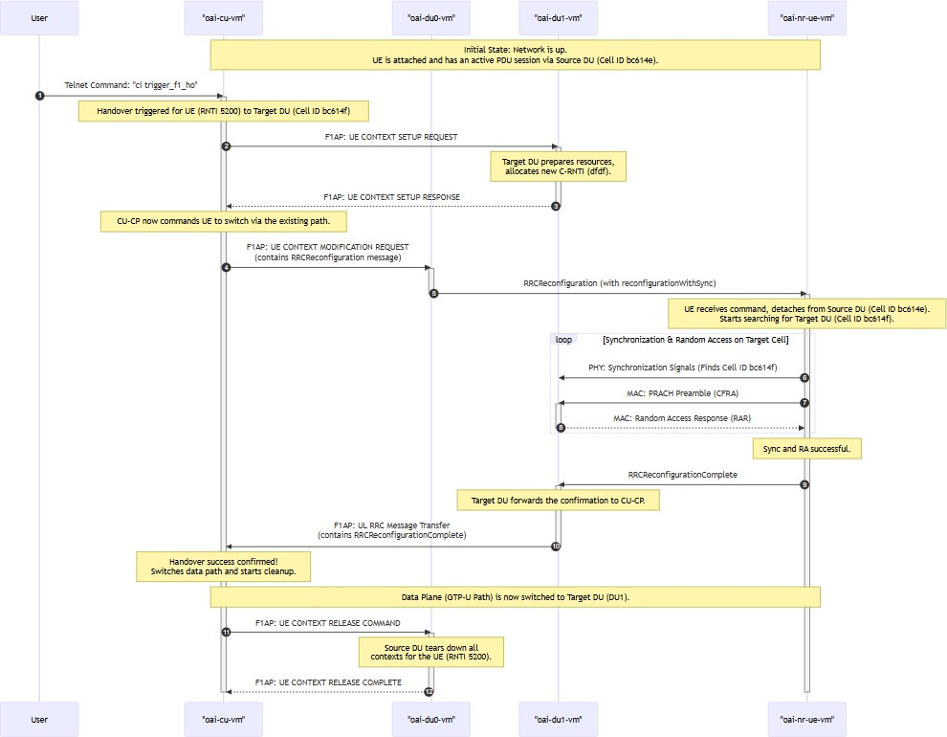

Step 1: Network Ready State - UE Attached via Source DU (DU0)
Initially, the network is stable. The UE has attached to the core through the source DU (
oai-
, PCI 0). Both DUs have established their F1 control connections with the CU-CP, and the CU-CP has established its E1 and NGAP connections.
du0-vm

Log: CU-CP ( ) shows all links are up and the UE is attached.
oai-cu-vm
The log shows the NGAP setup with the AMF is complete. It then accepts F1 connections
3585
3586

from both the source DU (ID
) and the target DU (ID
). Finally, it processes the

UE's connection through the source DU, establishing a PDU session.
[NGAP]
[GNB_APP]
... [NR_RRC]
assoc_id 6 [NR_RRC]
...
Received NGSetupResponse from AMF
[gNB 0] Received NGAP_REGISTER_GNB_CNF: associated AMF 1
Received F1 Setup Request from gNB_DU 3585 (oai-cu-cp) on

Accepting DU 3585 (oai-cu-cp), sending F1 Setup Response

Log: UE ( ) confirms synchronization and PDU session.
[NR_RRC]
assoc_id 7 [NR_RRC]
... [NR_RRC]
[NR_RRC]
Received F1 Setup Request from gNB_DU 3586 (oai-cu-cp) on
Accepting DU 3586 (oai-cu-cp), sending F1 Setup Response

[--] (cellID 0, UE ID 1 RNTI 5200) Create UE context... [UL] (cellID bc614e, UE ID 1 RNTI 5200) Received
RRCSetupComplete (RRC_CONNECTED reached)
...
[NGAP] PDUSESSIONSetup initiating message
[NR_RRC] UE 1: received PDU Session Resource Setup Request [NR_RRC] [DL] (cellID bc614e, UE ID 1 RNTI 5200) Generate RRCReconfiguration (bytes 283, xid 0)
[NR_RRC] [UL] (cellID bc614e, UE ID 1 RNTI 5200) Received
RRCReconfigurationComplete
oai-nr-ue-vm
The UE's log shows it synchronizing to the initial cell (PCI 0), completing the full NAS registration and security procedures, and finally receiving its IP address, which activates the
interface.
oaitun_ue1
[PHY]
... [NR_RRC] [NAS]
...
[NAS]
Initial sync successful, PCI: 0
State = NR_RRC_CONNECTED
Generate Initial NAS Message: Registration Request

[UE 0] Received NAS_DOWNLINK_DATA_IND type
FGS_REGISTRATION_ACCEPT with length 46
...
[NAS] Received PDU Session Establishment Accept, UE IPv4: 10.45.0.2 [OIP] Interface oaitun_ue1 successfully configured, IPv4 10.45.0.2, IPv6 (null)

Step 2: Manual Handover Trigger

You send the
ci trigger_f1_ho
catalyst for the entire sequence.
command to the telnet server on the CU-CP. This is the

Log: CU-CP ( ) receives the command and initiates the handover.
oai-cu-vm
The CU-CP receives the command and immediately begins the handover procedure,

targeting the UE (identified by its original RNTI ) towards the target DU (assoc_id ,
5200
7

which corresponds to PCI ).
1

[TELNETSRV] Telnet client connected....
[TELNETSRV] Command received: readc 17 filled 17 "ci trigger_f1_ho" [NR_RRC] Handover triggered for UE 1/RNTI 5200 towards DU 3586/assoc_id 7/PCI 1

Step 3: Handover Preparation & RRC Command
The CU-CP orchestrates the move. It first notifies the target DU to prepare resources. Once
confirmed, it sends the message to the UE, telling it to switch.
RRCReconfiguration

Log: Target DU ( ) prepares for the UE's arrival.
oai-du1-vm
The target DU receives an F1AP message from the CU-CP (not explicitly shown but implied). It sets up a new context for the incoming UE, assigning it a new temporary
identifier (C-RNTI ) and creating all necessary radio and transport layers for it.
dfdf

Log: UE ( oai-nr-ue-vm ) receives the handover command and starts the process.
[NR_MAC] Added new CFRA process for UE RNTI dfdf with initial CellGroup [RLC] Activated srb0 for UE 57311
[RLC] Added srb 1 to UE 57311 [RLC] Added srb 2 to UE 57311 [RLC] Added drb 1 to UE 57311
[GTPU] [94] Created tunnel for UE ID 57311, teid for incoming: 65e56dc2...
The UE receives the RRCReconfiguration message. The key fields
reconfigurationWithSync and the new C-RNTI instruct it to perform a handover.
dfdf
[NR_RRC]
[PDCP]
[PDCP] [NR_RRC] [NR_RRC]
... [MAC] [NR_MAC]
[NR_MAC]
RRCReconfiguration includes radio Bearer Configuration
SRB 2 re-established
DRB 1 re-established State = NR_RRC_CONNECTED
Processing reconfigurationWithSync
[UE 0] Applying CellGroupConfig from gNodeB
Received reconfigurationWithSync Configuring CRNTI dfdf

Step 4: UE Re-synchronization to Target Cell (PCI 1)
This is the most critical phase where the UE's physical layer finds and locks onto the new cell.

Log: UE ( ) successfully finds and synchronizes to PCI 1.
oai-nr-ue-vm

The UE's PHY layer immediately starts searching for the new cell ID ( successfully decodes its broadcast channel, confirming synchronization.
Nid_cell 1
) and

[NR_PHY]
[PHY]
... [PHY]
[PHY] [NR_PHY] [PHY]
[PHY]
Starting re-sync detection for target Nid_cell 1
[UE thread Synch] Running Initial Synch
Initial sync: pbch decoded sucessfully, ssb index 0
pbch rx ok. rsrp:54 dB/RE, adjust_rxgain:-4 dB Cell Detected with GSCN: 0...
Initial sync successful, PCI: 1
Got synch: hw_slot_offset 24, carrier off -186 Hz...

Step 5: Random Access on Target DU and Handover Completion
After synchronizing, the UE performs a contention-free random access (CFRA) on the new cell
RRCReconfigurationComplete

to announce its arrival and sends the handover.
message to finalize the

Log: Target DU ( ) detects the UE's PRACH and completes the access.
oai-du1-vm
The target DU sees the PRACH preamble from the UE, responds, and logs the successful
completion of the contention-free random access with the UE's new RNTI .
dfdf

Log: UE ( ) sends the final confirmation.
[NR_PHY]
44.0 dB... [NR_MAC]
... [NR_MAC]
[NR_MAC]
[RAPROC] 563.19 Initiating RA procedure with preamble 63, energy
563.19 UE RA-RNTI 0113 TC-RNTI dfdf: initiating RA procedure

(rnti 0xdfdf) CFRA procedure succeeded! Adding new UE context with RNTI 0xdfdf
oai-nr-ue-vm
The UE's MAC layer confirms the random access succeeded, and the RRC layer generates
the message to send up to the network.
RRCReconfigurationComplete
[MAC]
[UE 0][564.7][RAPROC] RA procedure succeeded. CFRA: RAR
successfully received.
...
[NR_RRC] rrcReconfigurationComplete Encoded 10 bits (2 bytes)

[NR_RRC] Logical Channel UL-DCCH (SRB1), Generating RRCReconfigurationComplete (bytes 2)

Step 6: Network Path Switch and Resource Cleanup
The CU-CP, having received the confirmation from the UE via the target DU, now finalizes the handover by switching the data path and telling the source DU to clean up.

Log: Source DU ( oai-du0-vm ) is commanded to release the UE's context.
The source DU receives a TransmissionActionIndicator with Stop value for the original UE RNTI 5200 . After a timer, it tears down all resources associated with that UE.

Log: CU-CP ( oai-cu-vm ) logs the final success and triggers the cleanup.
[NR_MAC]
for UE 5200
... [GTPU]
[RLC]
[NR_MAC]
gNB-DU received the TransmissionActionIndicator with Stop value
[94] Deleted all tunnels for ue id 20992 (1 tunnels deleted)
Remove UE 20992 Remove NR rnti 0x5200
The CU-CP receives the RRCReconfigurationComplete via the new path (target DU), updates the UE's RNTI from 5200 to dfdf , and declares the handover complete. It then

explicitly triggers the release of the UE context on the source DU (assoc_id ).
6
[NR_RRC] UE 1 handover: update RNTI from 5200 to dfdf [NR_RRC] [UL] (cellID bc614f, UE ID 1 RNTI dfdf) Received RRCReconfigurationComplete
[NR_RRC] handover for UE 1/RNTI dfdf complete!
[NR_RRC] UE 1 Handover: trigger release on DU assoc_id 6

At this point, the procedure is complete. The UE is actively communicating through the target DU, and the data from the continuous ping test is flowing seamlessly through the new data path.

Part 10: CRITICAL Cleanup
To avoid ANY charges after you are finished, you MUST tear down your environment.

Delete the VMs:

Go to Compute Engine > VM instances. Select all five VMs and click DELETE.

Delete the Cloud NAT Gateway:
Go to Network services > Cloud NAT.
Select the gateway and click DELETE.
oai-5g-nat

Delete VPC, Firewall Rules, and Static IPs:
Optionally, delete these components to leave your project completely clean.

Links
F1-Handover procedure draw.io --> https://drive.google.com/file/d/1YerukXAROqbL3o8jTNwJxVJxzveAqrha/view?usp=sharing F1-Handover for rf-sim setup draw.io --> https://drive.google.com/file/d/1wpv_xx1RJUNTTTLFXiSuFpAVwUbzWNB_/view? usp=sharing
Detailed log files --> Demo video -->

